θωερτψυιοπασδφγηϕκλζξχϖβνμθωερτψυιοπασδφγηϕκλζξχϖβνμθωερτψυιοπασδφγηϕκλζξχϖβνμθωερτψυιοπασδφγηϕκλζξχϖβνμθωερτψυιοπασδφγηϕκλζξχϖβνμθωερτψυιοπασδφγηϕκλζξχϖβνμθωερτψυιοπασδφγηϕκτψυιοπασδφγηϕκλζξχϖβνμθωερτψυιοπασδφγηϕκλζξχϖβνμθωερτψυιοπασδφγηϕκλζξχϖβνμθωερτψυιοπασδφγηϕκλζξχϖβνμθωερτψυιοπασδφγηϕκλζξχϖβνμθωερτψυιοπασδφγηϕκλζξχϖβνμθωερτψυιοπασδφγηϕκλζξχϖβνμθωερτψυιοπασδφγηϕκλζξχϖβνμθωερτψυιοπασδφγηϕκλζξχϖβνμθωερτψυιοπασδφγηϕκλζξχϖβνμρτψυιοπασδφγηϕκλζξχϖβνμθωερτψυιοπασδφγηϕκλζξχϖβνμθωερτψυιοπασδφγηϕκλζξχϖβνμθωερτψυιοπασδφγηϕκλζξχϖβνμθωερτψυιοπασδφγηϕκλζξχϖβνμθωερτψυιοπασδφγηϕκλζξχϖβνμθωερτψυιοπασδφγηϕκλζξχϖβνμθωερτψυιοπασδφγηϕκλζξχϖβνμθωερτψυιοπασδφγηϕκλζξχϖβνμθωερτψυιοπασδφγηϕκλζξχϖβνμθωερτψυιοπασδφγηϕκλζξχϖβνμθωερτψυιοπασδφγηϕκλζξχϖβνμθωερτψυιοπασδφγηϕκλζξχϖβνμρτψυιοπασδφγηϕκλζξχϖβνμθωερτψυιοπασδφγηϕκλζξχϖβνμθωερτψυιοπασδφγηϕκλζξχϖβνμθωερτψυιοπασδφγηϕκλζξχϖβνμθωερτψυιοπασδφγηϕκλζξχϖβνμθωερτψυιοπασδφγηϕκλζξχϖβνμθωερτψυιοπασδφγηϕκλζξχϖβνμθωερτψυιοπασδφγηϕκλζξχϖβνμθωερτψυιοπασδφγηϕκλζξχϖβνμθωερτψυιοπασδφγηϕκλζξχϖβνμθωερτψυιοπασδφγηϕκλζξχϖβνμθωερτψυιοπασδφγηϕκλζξχϖβνμθωερτψυιοπασδφγηϕκλζξχϖβνμρτψυιοπασδφγηϕκλζξχϖβνμθωερτψυιοπασδφγηϕκλζξχϖβνμθωερτψυιοπασδφγηϕκλζξχϖβνμθωερτψυιοπασδφγηϕκλζξχϖβνμθωερτψυιοπασδφγηϕκλζξχϖβνμθωερτψυιοπασδφγηϕκλζξχϖβνμθωερτψυιοπασδφγηϕκλζξχϖβνμθωερτψυιοπασδφγηϕκλζξχϖβνμθωερτψυιοπασδφγηϕκλζξχϖβνμθωερτψυιοπασδφγηϕκλζξχϖβνμθωερτψυιοπασδφγηϕκλζξχϖβνμθωερτψυιοπασδφγηϕκλζξχϖβνμθωερτψυιοπασδφγηϕκλζξχϖβνμρτψυιοπασδφγηϕκλζξχϖβνμθωερτψυιοπασδφγηϕκλζξχϖβνμθωερτψυιοπασδφγηϕκλζξχϖβνμθωερτψυιοπασδφγηϕκλζξχϖβνμθωερτψυιοπασδφγηϕκλζξχϖβνμθωερτψυιοπασδφγηϕκλζξχϖβνμθωερτψυιοπασδφγηϕκλζξχϖβνμθωερτψυιοπασδφγηϕκλζξχϖβνμθωερτψυιοπασδφγηϕκλζξχϖβνμθωερτψυιοπασδφγηϕκλζξχϖβνμθωερτψυιοπασδφγηϕκλζξχϖβνμθωερτψυιοπασδφγηϕκλζξχϖβνμθωερτψυιοπασδφγηϕκλζξχϖβνμρτψυιοπασδφγηϕκλζξχϖβνμθωερτψυιοπασδφγηϕκλζξχϖβνμθωερτψυιοπασδφγηϕκλζξχϖβνμθωερτψυιοπασδφγηϕκλζξχϖβνμθωερτψυιοπασδφγηϕκλζξχϖβνμθωερτψυιοπασδφγηϕκλζξχϖβνμθωερτψυιοπασδφγηϕκλζξχϖβνμθωερτψυιοπασδφγηϕκλζξχϖβνμθωερτψυιοπασδφγηϕκλζξχϖβνμθωερτψυιοπασδφγηϕκλζξχϖβνμθωερτψυιοπασδφγηϕκλζξχϖβνμθωερτψυιοπασδφγηϕκλζξχϖβνμθωερτψυιοπασδφγηϕκλζξχϖβνμρτψυιοπασδφγηϕκλζξχϖβνμθωερτψυιοπασδφγηϕκλζξχϖβνμθωερτψυιοπασδφγηϕκλζξχϖβνμθωερτψυιοπασδφγηϕκλζξχϖβνμθωερτψυιοπασδφγηϕκλζξχϖβνμθωερτψυιοπασδφγηϕκλζξχϖβνμθωερτψυιοπασδφγηϕκλζξχϖβνμθωερτψυιοπασδφγηϕκλζξχϖβνμθωερτψυιοπασδφγηϕκλζξχϖβνμθωερτψυιοπασδφγηϕκλζξχϖβνμθωερτψυιοπασδφγηϕκλζξχϖβνμθωερτψυιοπασδφγηϕκλζξχϖβνμθωερτψυιοπασδφγηϕκλζξχϖβνμρτψυιοπασδφγηϕκλζξχϖβνμθωερτψυιοπασδφγηϕκλζξχϖβνμθωερτψυιοπασδφγηϕκλζξχϖβνμθωερτψυιοπασδφγηϕκλζξχϖβνμθωερτψυιοπασδφγηϕκλζξχϖβνμθωερτψυιοπασδφγηϕκλζξχϖβνμθωερτψυιοπασδφγηϕκλζξχϖβνμθωερτψυιοπασδφγηϕκλζξχϖβνμθωερτψυιοπασδφγηϕκλζξχϖβνμθωερτψυιοπασδφγηϕκλζξχϖβνμθωερτψυιοπασδφγηϕκλζξχϖβνμθωερτψυιοπασδφγηϕκλζξχϖβνμθωερτψυιοπασδφγηϕκλζξχϖβνμθωωερτψυιοπασδφγηϕκλζξχϖβνμθωερτψυιοπασδφγηϕκλζξχϖβνμθωερτψυιοπασδφγηϕκλζξχϖβνμθωερτψυιοπασδφγηϕκλζξχϖβνμ
Unit 21: Single Camera Techniques – Camera Shots, Angles and Movements
Tutor: Conor Glynn
Student: Aisling Sweeney

Single Camera Techniques: Formats
Camera Shots, Angles and Movements

In this essay, I will be demonstrating my knowledge for the different types of camera shots, angles and movements. Camera shots, angles and movements are an important element to any production, a pacific type of shot or angle can help create an impact to the audience viewing the filming with the usage of emotions.

Camera Shots:

Close-up Shot – These are the most common shot that are used throughout film/television. A close-up shot is when a camera tightly frames a person or an object. Close-ups are one of the standard shots used regularly with medium shots and long shots; they are used best at capturing the characters emotions.

Examples for Close-up Shots:

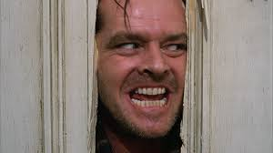
Close-up taken from the film: The Shining (1980)

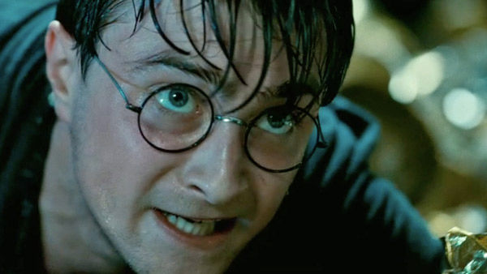
Close-up taken from the film: Harry Potter - Deathly Hallows

Extreme Close-up - These shots are commonly used in film and television productions to allow the audience to focus more in depth on a certain detail/feature on the character. Mainly eyes are used in close-ups to emphasis what type of emotion that the character is feeling and also hints to what is happening in the scene without giving anything away.

Examples for Extreme Close-ups:

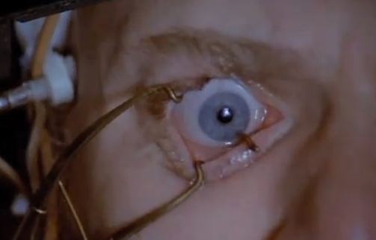

Extreme Close-up taken from the film: A Clockwork Orange (1971)
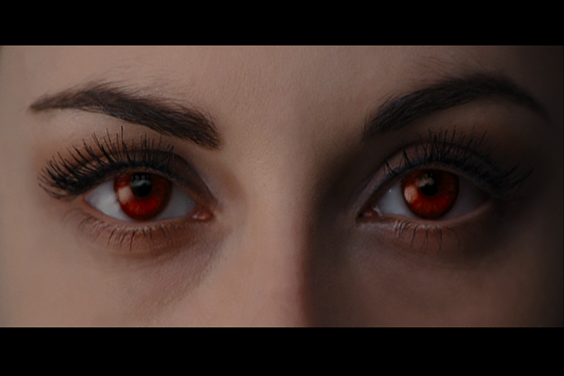

Extreme Close-up taken from the film:
Twilight Saga – Breaking Dawn Pt.1

Wide Shots - these types of shots that are used to fill the screen with the subject matter, for example: a character or an object. These shots are typically used to show a character walking or running.

Ex amples for Wide Shots:

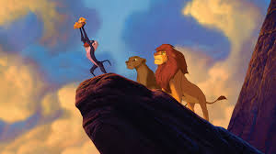
Wide shot taken from film: The Lion King (1994)

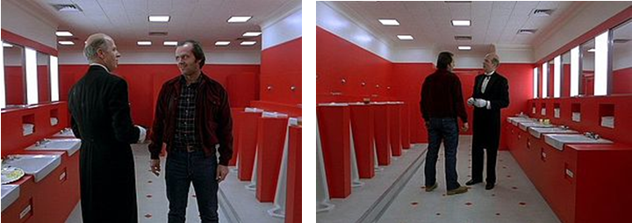
Wide shot taken from the film: The Shining (1980)

Extreme Wide Shot – Extreme wide shots are knowingly as establishing shots, these are mainly use to showcase the location that a scene takes place in.

Ex amples for Extreme Wide Shot:

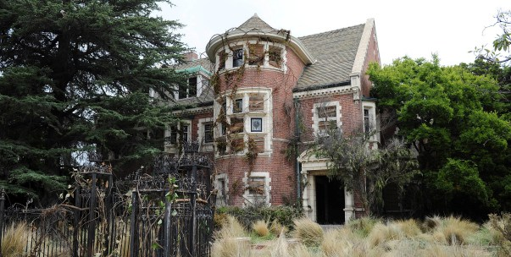
Extreme wide shot taken from American Horror Story: Murder House, Season 1 (2001)

Extreme Wide shot taken from: Game of Thrones
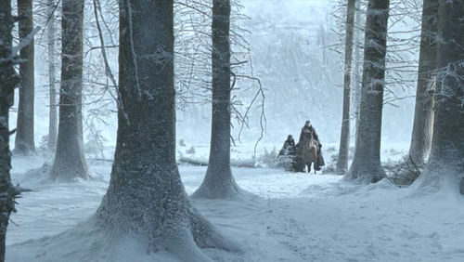

Mid Shot - These shots are used more commonly in film and video production during conversation between characters, they will usually show a character from the waist upwards this allows the audience to view what facial expressions and body language is occurring during the conversation.

Ex amples for Mid Shot:

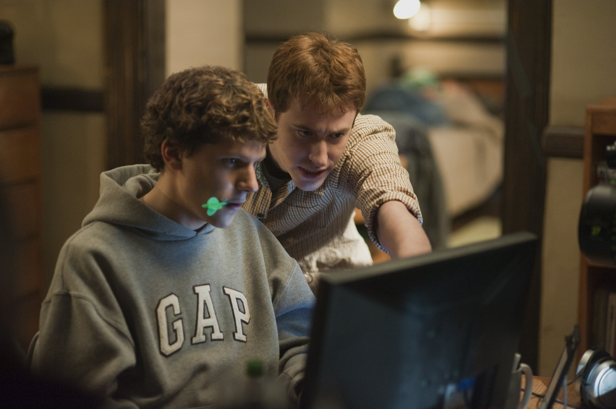
Mid shot taken from the film: Social Network (2010)

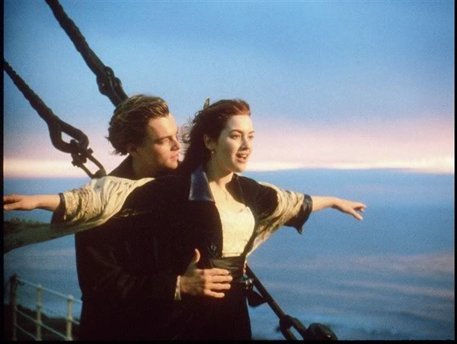

Mid shot taken from film: The Titanic (1997)

Point of View Shot (POV) – These shots are used throughout film and video production when the director wants the audience to see an object or character from another characters perspective.

Ex amples for Point of View Shot (POV):

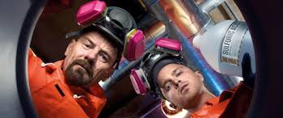
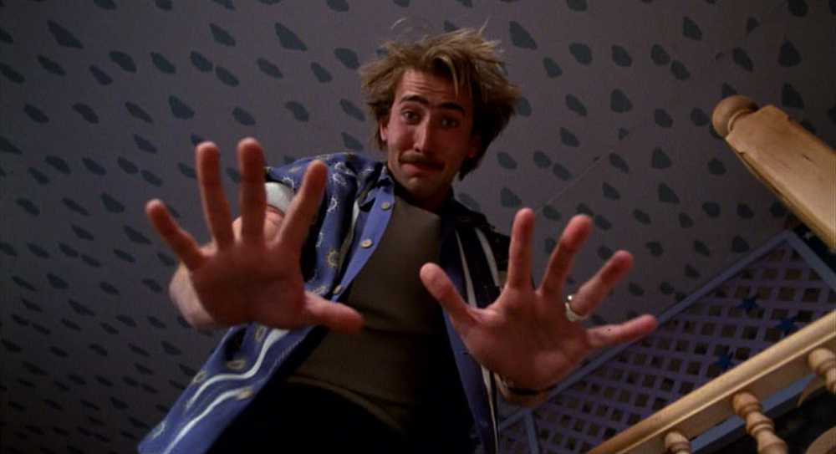
Point of View shot taken from: Breaking Bad (2008)

Point of View shot taken from the film: Raising Arizona (1987)

Over the Shoulder Shot – This is shot that is used during a scene in which a conversation is taking place. This is shot is when the camera operator will place the camera so that it is peering over one characters shoulder while pointing at another character.

Examples for Over the Shoulder Shot:

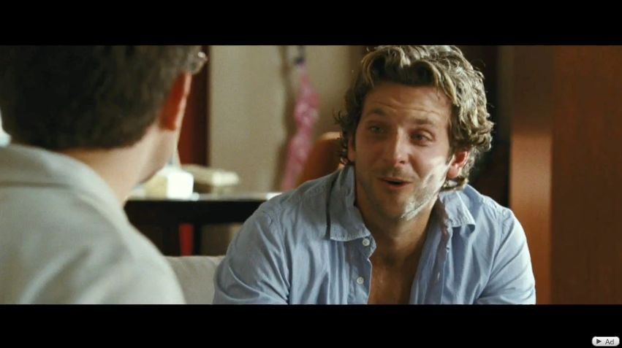
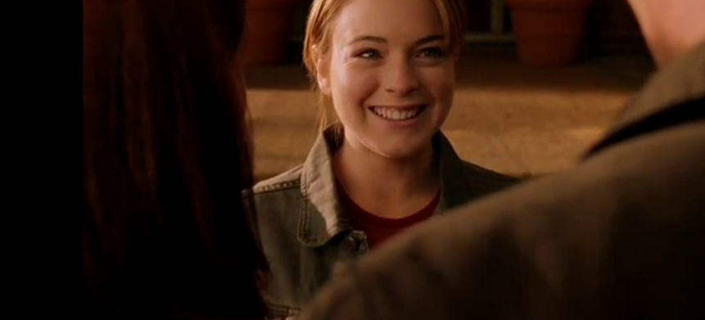
Over the Shoulder shot from the film: The Hangover (2009)

Over the Shoulder shot from the film: Mean Girls (2004)

Camera Angles

High Angle: A high angle shot is a type of cinematic technique when the camera is camera is pointing down on the subject to create vulnerability or powerless, this allows the audience to have some sort of sympathy towards the character and what is happening in the production.

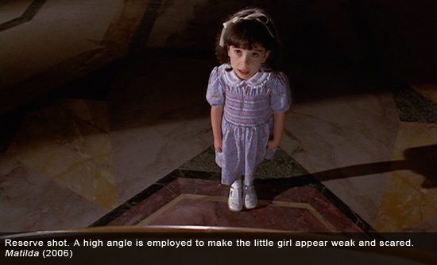
Examples of High Angles Shot:

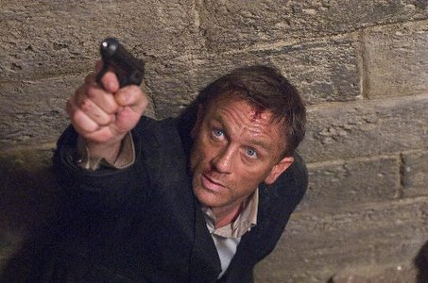
High Angle Shot from the film: Matilda (1996)

High Angle Shot from the film: James Bond: Quantum of Solace (2008)

Low Angle Shot: Low Angles shots is when a camera is angled at a low position where the eyeline is looking up towards the character, this effect is used to make the subject look strong and powerful. This shot allows the audience to become more aware of the scene, usually these scenes are taken place outside to give the audience a feel of the scenery.

Examples of Low Angle Shot:

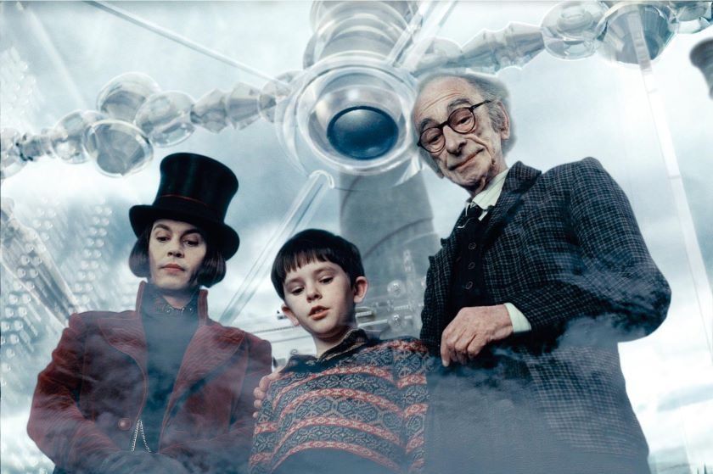

Low Angle Shot from the film: Charlie and the Chocolate Factory (2005)

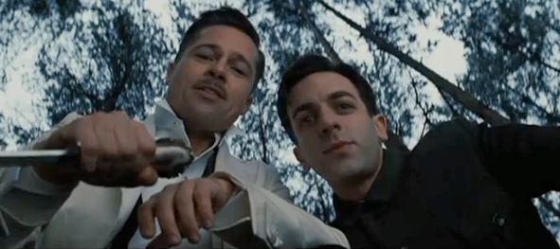
Low Angle Shot from the film: Inglorious Bastards (2009)

Birds Eye View Angle Shot: This angle is an elevated view of the subject from above, the camera is positioned at eye level, and it allows the audience to have the perspective of the scene through the observer as a bird. This angle is mainly used during conversation scenes.

Examples of Birds Eye View Angle Shot:

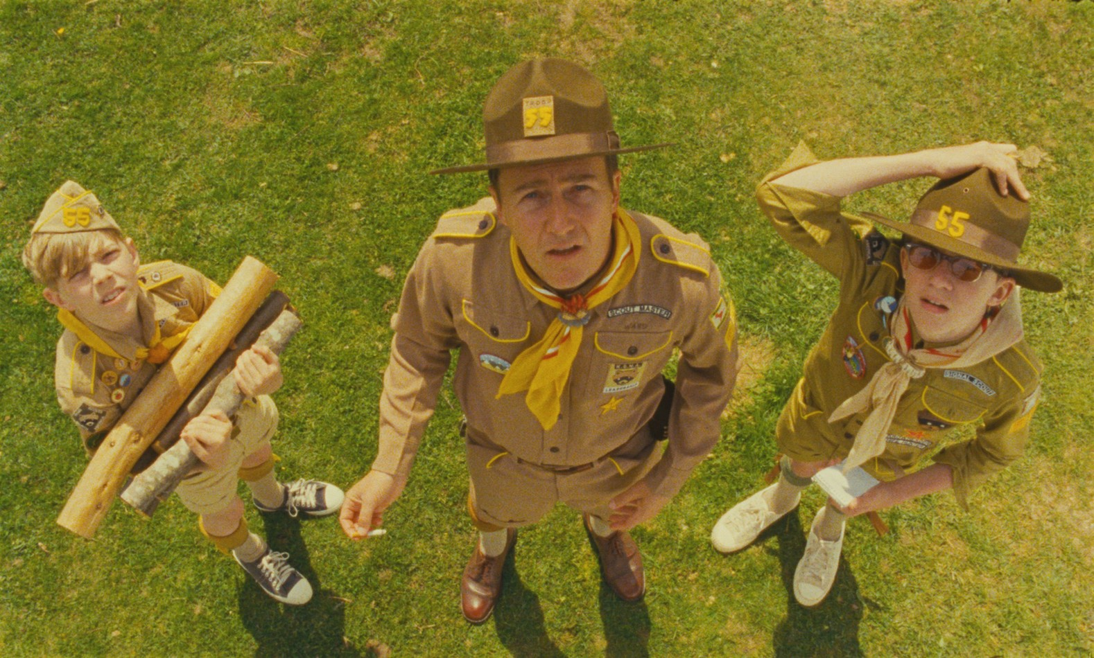
Birds Eye View Angle Shot from the film: Moonrise Kingdom (2012)

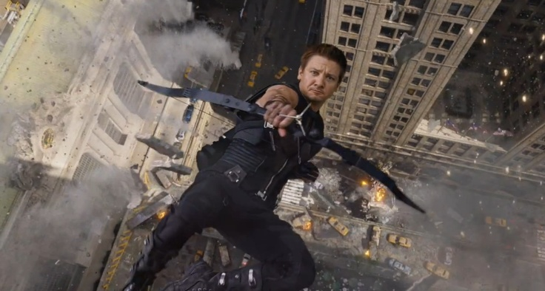
Birds Eye View Angle Shot from the film: The Avengers (2012)

Eye Level Angle: This angle is a neutral shot where the camera is positioned as if the audience is viewing the character; the characters head is at eye level so the audience can directly look at their face. Most commonly used in conversation scenes.

Examples of Eye Level Angle Shots:

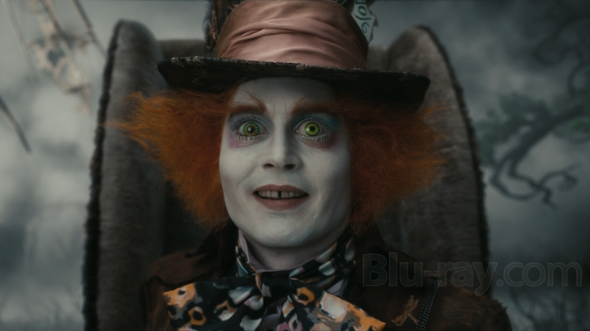

Eye Level Angle Shot from the film: Alice and Wonderland (2010)

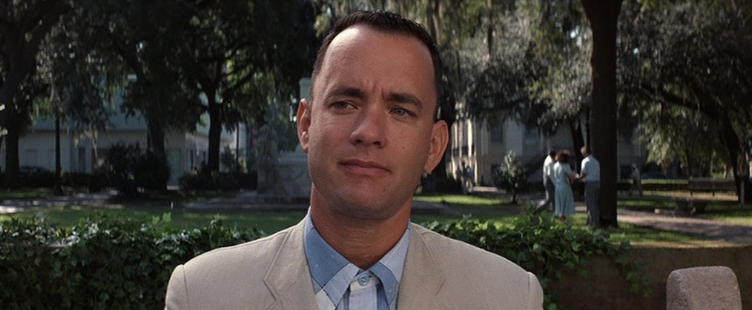

Eye Level Angle Shot from the film: Forrest Gump (1994)

Canted Angle: Canted angle is famously known as a Dutch angle/ Dutch tilt, it’s a type camera shot that the camera is angle on its side to create a feeling of terror. It’s most commonly used in horrors and thrillers.

Examples of Canted Angle:

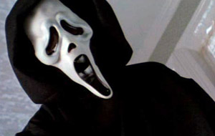
Canted Angle Shot from the film: Scream (1996)

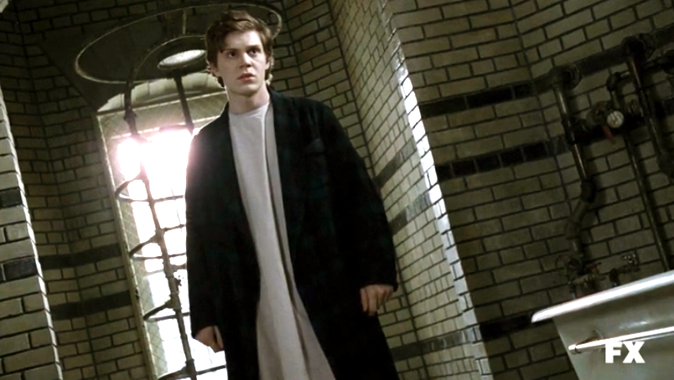
Canted Angle Shot from the TV Series: American Horror Story – Season 2: Asylum (2012)

Camera Movements

Pan – The camera is placed on to a tripod and the camera is moved slowly to capture/follow what action the subject is doing.

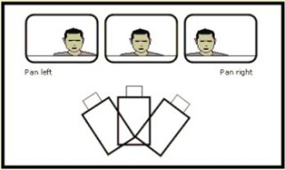

Tilts - Tilting is a type of cinematographic technique in which the camera is stationary and rotates in a vertical place also known as a tilting plane. Rotation that is done in a horizontal plane is known as “panning”.

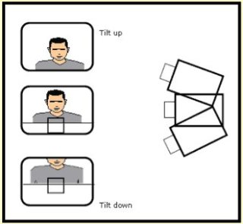

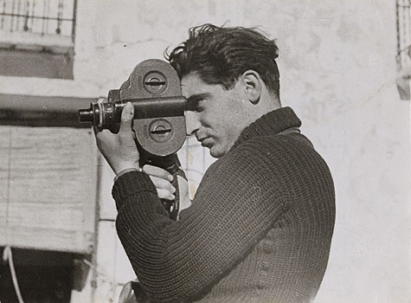

Hand Held – Hand-held in Fim/Video production is a technique in which the camera operator’s hand is controlling the camera freely without the need of a tripod. It can come in helpful in different circumstances but sometimes, it can be unsteady and put the viewer off.

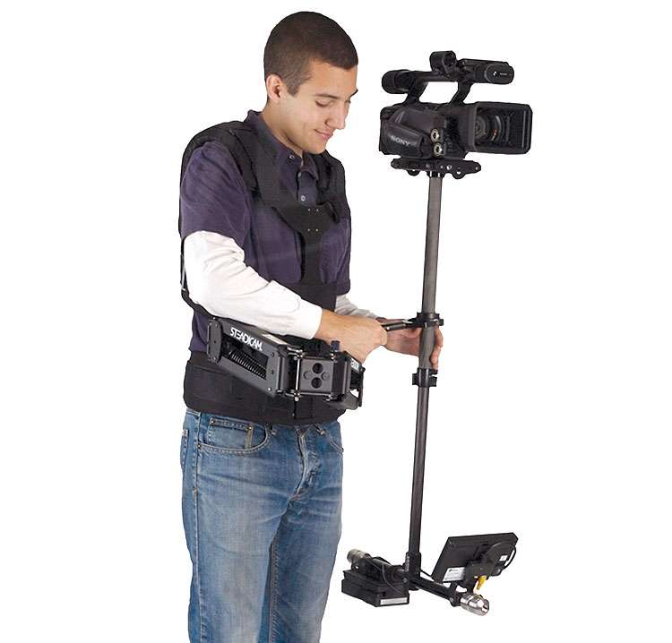
SteadiCam – Is a type of equipment that is used defeat any shaking in a production it’s an alternative to using hand-held for much smoother/professional looking shots. Steadicams have a body mount and weights that allows the weight to distribute evenly to the camera so it will cause the shaking during filming.

Crane Shots - In film and video production, a crane shot is a shot taken by a camera on a crane or jib. The most obvious uses are to view the actors from above or to move up and away from them, a common way of ending a movie
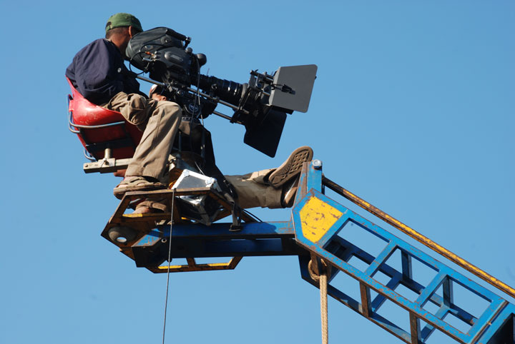

Ariel Shots – This when a scene is being filmed from a helicopter or a drone. These shots are commonly used as an establishing shot or for a birds eye view shot.

Dolly Zoom – It can be also known as a “Vertigo Shot”, Dolly zoom is a type of technique that that was developed by the late Alfred Hitchcock after fainting at party due to a vertigo episode. To create a dolly zoom shot, the camera must be going the complete opposite direction in which the camera zoom is going.

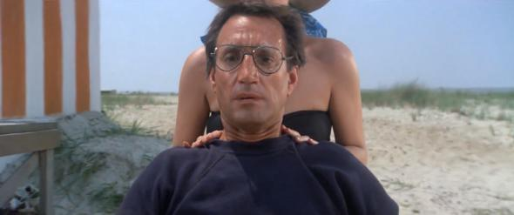
One of the most famous dolly zoom shot’s in film history – Jaws (1975)

Conclusion:
From looking at the different types of cinematography angles, shots and movements that are used throughout various film and video productions, viewers wouldn’t enjoy or have the same appreciation to film without these techniques, all these angles, shots and movements are extremely important for anyone young filmmaker who wants to create something enjoyable as they give films more depth and structure to view.

